Higher Order Linear Differential Equations

- Higher−Order Differential Equations
( Sec. 2.13 of the Textbook )

Consider the differential equation:
y^{(n)} + p_{n−1}(x) y^{(n-1)} + . . . + p₁(x) y' + p₀(x) y = 0
with the initial conditions
y(x₀) = k₀, y'(x₀) = k₁, . . ., y^{(n-1)}(x₀) = k_{n−1}

General Solution
A general solution of the above n^{th} order homogeneous linear differential equation on some interval I is a function of the form
y(x) = c₁ y₁(x) + c₂ y₂(x) + ... + c_{n} y_{n}(x)
where y₁ , . . ., y_{n} are linearly independent solutions (basis) on I.

Theorem − Existence and Uniqueness of IVP
If the p₀(x), p₁(x), . . ., p_{n−1}(x) in the differential equations are continuous on an open interval I, then the initial value problem [with x₀ in I] has a unique solution in I.

Wronskian
The Wronskian of y₁, y₂, . . ., y_{n} is defined as
W(y₁, y₂, . . ., y_{n}) =

Theorem − Linear Dependence and Independence of Solutions
(p. 127 of Textbook)
Let p₀(x), p₁(x), . . ., p_{n−1}(x) be continuous in I, [x₀, x₁], and let y₁, y₂, . . ., y_{n} be n solutions of the differential equation. Then
(1) W(y₁, y₂, . . ., y_{n}) is either zero for all x ∈ I or for no value of x ∈ I.
(2) y₁, y₂, . . ., y_{n} are linearly independent if and only if
W(y₁, y₂, . . ., y_{n}) ≠ 0

Theorem − Existence of a General Solution (See Textbook p. 128)

Theorem − General Solution (See Textbook p. 129)

[Exercise] Consider the third−order equation
y''' + a(x) y'' + b(x) y' + c(x) y = 0
where a, b and c are continuous functions of x in some interval I. The Wronskian of y₁(x), y₂(x), and y₃(x) is defined as
W =
where y₁, y₂ and y₃ are solutions of the differential equation.
(a) Show that W satisfies the differential equation W' + a(x) W = 0
(b) Prove that W is always zero or never zero.
(c) Can you extend the above results to n^{th}–order linear differential equations?

2 nth-Order Homogeneous Equations with Constant Coefficients

(Sec. 2.14 of Textbook)
y^{(n)} + a_{n−1} y^{(n-1)} + . . . + a₁ y' + a₀ y = 0 Differential Equation
λ^{n} + a_{n−1} λ^{n-1} + . . . + a₁ λ + a₀ = 0 Characteristic Equation

Case I Distinct Roots, λ₁, λ₂, . . ., λ_{n}
The corresponding linearly independent solutions are
e, e, . . ., e

Case II Multiple Roots, λ₁ = λ₂ = . . . = λ_{m} = λ
The corresponding linearly independent solutions are
e, x e, xe, . . ., xe

Case III Complex Simple Roots λ₁ = γ + i ω , λ₂ = γ − i ω
The corresponding linearly independent solutions are
ecos ωx , esin ωx

Case IV Complex Multiple Roots
λ₁ = λ₃ = λ₅ = . . . = λ_{2m−1} = γ + i ω
λ₂ = λ₄ = λ₆ = . . . = λ_{2m} = γ − i ω
The corresponding linearly independent solutions are
ecos ωx, x ecos ωx, . . ., xecos ωx
esin ωx, x esin ωx, . . ., xesin ωx

[Example] y''' − 3 y'' − 10 y' + 24 y = 0
[Solution] The characteristic equation is
λ³ − 3 λ² − 10 λ + 24 = 0
or ( λ − 2 ) ( λ + 3 ) ( λ − 4 ) = 0
or λ = 2, −3, 4 (Case I)
⇒ y = c₁ e+ c₂ e+ c₃ e

[Example] y– 4 y''' + 6 y'' − 4 y' + y = 0
[Solution] The characteristic equation is
λ⁴ − 4 λ³ + 6 λ² − 4 λ + 1 = 0
or ( λ − 1 )⁴ = 0
or λ = 1, 1, 1, 1 (Case II)
⇒ y = c₁ e+ c₂ x e+ c₃ xe+ c₄ xe

[Example] y– 2 y+ 8 y'' − 12 y' + 8 y = 0
[Solution] The characteristic equation is
λ⁵ − 2 λ⁴ + 8 λ² − 12 λ + 8 = 0
or ( λ + 2 ) ( λ² − 2 λ + 2 )² = 0
or λ = –2, 1 + i, 1 − i, 1 + i, 1 − i (Case IV)
⇒ y = c₁ e+ c₂ ecos x + c₃ x ecos x
+ c₄ esin x + c₅ x esin x

[Exercise 1] Reduction of Order of Higher−Order Equations ( Textbook, p. 137, Problem 20 )

[Exercise 2] Consider the third−order equation
y''' + a(x) y'' + b(x) y' + c(x) y = 0
and let y₁(x) and y₂(x) be two linearly independent solutions. Define y₃(x) = v(x) y₁(x) and assume that y₃ is a solution to the equation.
(a) Find a second−order differential equation that is satisfied by v'.
(b) Show that (y₂/y₁)' is a solution of this equation.
(c) Use the result of part (b) to find a second, linearly independent solution of the equation derived in part (a).

[Exercise 3] [Euler-Cauchy Equation of the Third Order] The Euler equation of the third order is
x³ y''' + a x² y'' + b x y' + c y = 0
Show that y = x^{m} is a solution of the equation if and only if m is a root of the characteristic equation
m³ + ( a − 3 ) m² + ( b − a + 2 ) m + c = 0
What is the characteristic equation for the n^{th} order Euler equation?

- Nonhomogeneous Equations
( Sec. 2.15 of Textbook )

y^{(n)} + p_{n−1}(x) y^{(n−1)} + . . . + p₁(x) y' + p₀(x) y = r(x)
⇒ y(x) = y_{h}(x) + y_{p}(x)
where again y_{h}(x) = c₁ y₁ + c₂ y₂ + ... + c_{n} y_{n} is a general solution of the homogeneous equation and y_{p}(x) is a particular solution to the nonhomogeneous equation.

(1) Method of Undetermined Coefficients
Same as in the Chapter 2.
In summary, for a constant coefficient nonhomogeneous linear differential equation of the form
y^{(n)} + a y^{(n−1)} + . . . + f y' + g y = r(x)
we have the following rules for the method of undetermined coefficients:

(A) Basic Rule: If r(x) in the nonhomogeneous differential equation is one of the functions in the first column in the following table, choose the corresponding function y_{p} in the second column and determine its undetermined coefficients by substituting y_{p} and its derivatives into the nonhomogeneous equation.

(B) Modification Rule: If any term of the suggested solution y_{p}(x) is the solution of the corresponding homogeneous equation, multiply y_{p} by x repeatedly until no term of the product x^{k}y_{p} is a solution of the homogeneous equation. Then use the product x^{k}y_{p} to solve the nonhomogeneous equation.

(C) Sum Rule: If r(x) is sum of functions listed in several lines of the first column of the following table, then choose for y_{p} the sum of the functions in the corresponding lines of the second column.

Table for Choosing y_{p}
r(x) y_{p}(x)
P_{n}(x) a₀ + a₁ x + . . . + a_{n} x^{n}
P_{n}(x) e^{ax} (a₀ + a₁ x + . . . + a_{n} x^{n}) e^{ax}

where P_{n}(x) and Q_{n}(x) are polynomials in x of degree n (n ≥ 0).
Please read the Textbook for examples.

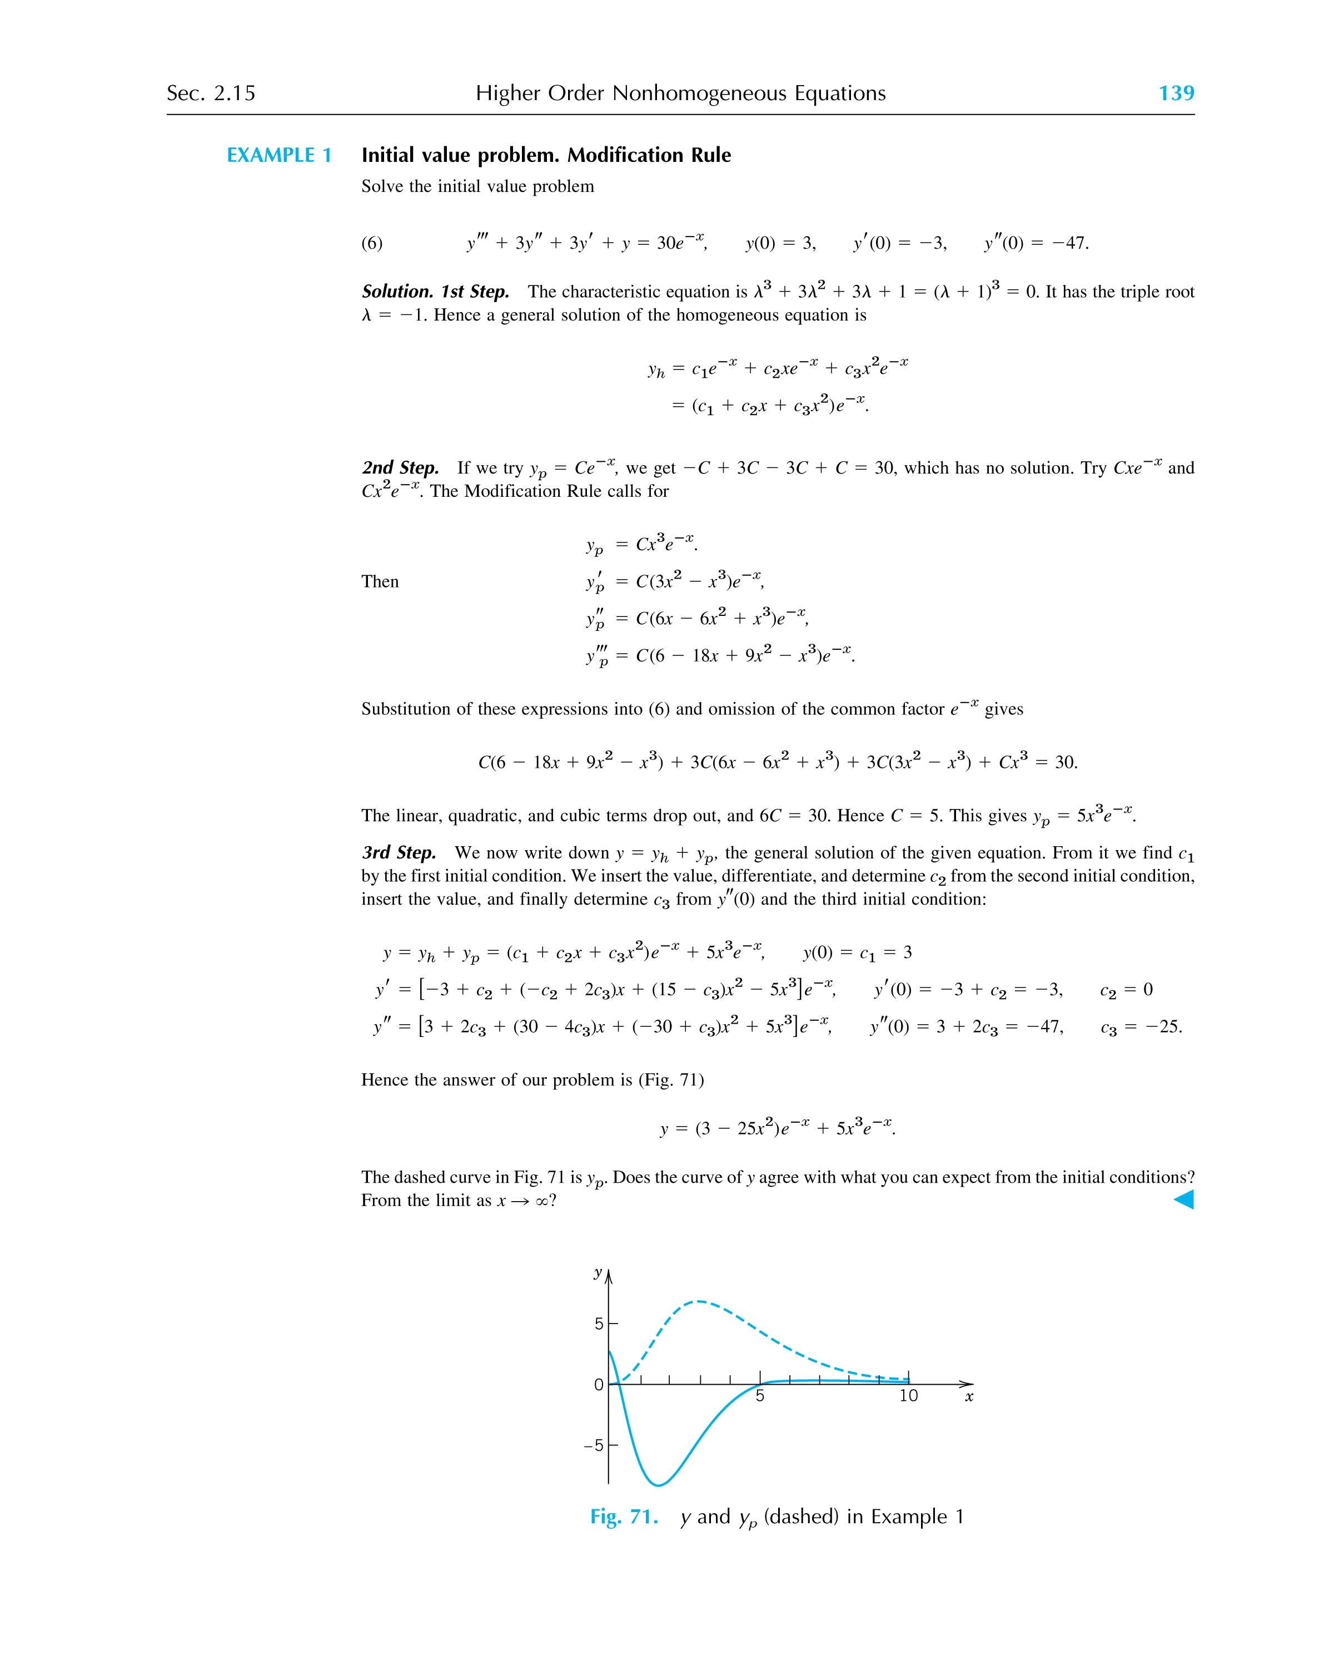

(2) Method of Variation of Parameters
y^{(n)} + p_{n-1}(x) y^{(n-1)} + . . . + p₁(x) y' + p₀(x) y = r(x)
Given ⇒ y_{h} = c₁ y₁ + c₂ y₂ + . . . + c_{n} y_{n}

Assume y_{p} = u₁ y₁ + u₂ y₂ + . . . + u_{n} y_{n}
where u₁, ..., u_{n} are functions of x. Since the particular solution satisfies the non-homogeneous differential equation, we have
y_{p}^{(n)} + p_{n-1}(x) y_{p}^{(n-1)} + . . . + p₁(x) y_{p}' + p₀(x) y_{p} = r(x)
Now y_{p}' = u₁' y₁ + . . . + u_{n}' y_{n} + u₁ y₁' + . . . + u_{n} y_{n}'
Assume u₁' y₁ + u₂' y₂ + . . . + u_{n}' y_{n} = 0 ⇐
then y_{p}' = u₁ y₁' + . . . + u_{n} y_{n}'
and y_{p}'' = u₁' y₁' + . . . + u_{n}' y_{n}' + u₁ y₁'' + . . . + u_{n} y_{n}''
Again, we assume
u₁' y₁' + u₂' y₂' + . . . + u_{n}' y_{n}' = 0 ⇐
we have
y_{p}'' = u₁ y₁'' + . . . + u_{n} y_{n}''
After differentiation n times, we have a set of simultaneous differential equations of u₁', u₂' . . ., u_{n}':
y₁u₁' + y₂u₂' + y₃u₃' + . . . + y_{n}u_{n}' = 0
y₁'u₁' + y₂'u₂' + y₃'u₃' + . . . + y_{n}'u_{n}' = 0
y₁''u₁' + y₂''u₂' + y₃''u₃' + . . . + y_{n}''u_{n}' = 0
....
y₁^{(n-2)}u₁' + y₂^{(n-2)}u₂' + y₃^{(n-2)}u₃' + . . . + y_{n}^{(n-2)}u_{n}' = 0
y₁^{(n-1)}u₁' + y₂^{(n-1)}u₂' + y₃^{(n)}u₃' + . . . + y_{n}^{(n-1)}u_{n}' = r(x)

The solutions of u₁', u₂', ..., u_{n}' are
u₁' = = r(x)
u₂' = = r(x)
.....
u_{n}' = = r(x)
Thus, we have
y_{p}(x) = y₁ r(x) dx + y₂ r(x) dx
+ . . . + y_{n} r(x) dx

[Example] x³y''' − 4x²y'' + 8xy' − 8y = 6x³(x²+1)^{-3/2}, x > 0
[Solution] Important! We must re-write the above equation in the standard form:
y''' − y'' + y' − y = r(x) = 6(x² + 1)^{-3/2}

The solution of the corresponding homogeneous equation is
y_{h} = c₁ x + c₂ x² + c₃ x⁴
or y₁ = x, y₂ = x², y₃ = x⁴

⇒ W(x) = = 6 x⁴ ( ≠ 0 on (0, ∞) )

u₁' =
=
= 2 x ( x² + 1 )^{-3/2}
u₂' = − 3 ( x² + 1 )^{-3/2}
u₃' = x⁻² ( x² + 1 )^{-3/2}

After integration, we have
u₁ =
u₂ =
u₃ =

∴ y_{p} = u₁ y₁ + u₂ y₂ + u₃ y₃ = − 2 x ( x² + 1 )^{-3/2}

⇒ y = c₁ x + c₂ x² + c₃ x⁴ − 2 x ( x² + 1 )^{-3/2}

[Exercises] Do Problems 1−13 on p. 141 of the Textbook.

